**Installing Pythong/Anaconda:**

Go to Link: <https://www.anaconda.com/products/individual>

Click “download”

Choose the Python 3.7 “64-Bit Graphical Installer”, save and run



Installer:

1. Click “I Agree”

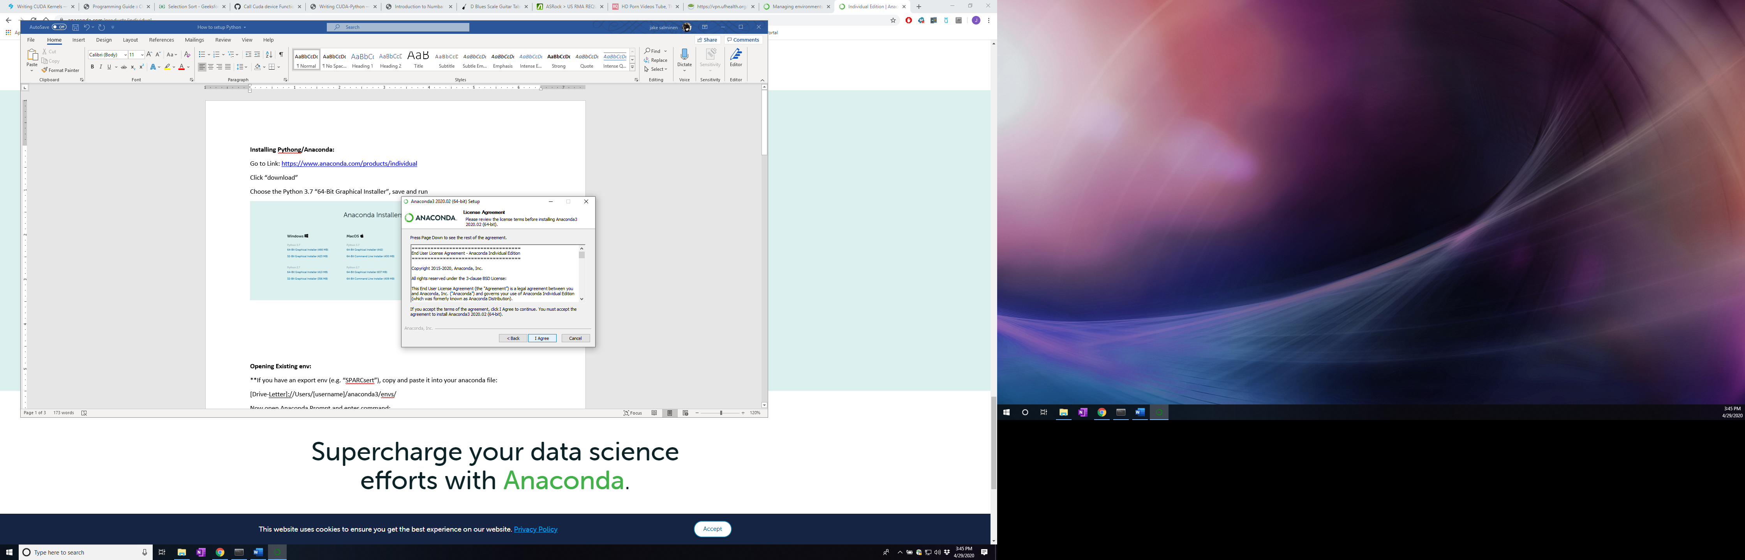  
2) Install for “Just Me” and click Next

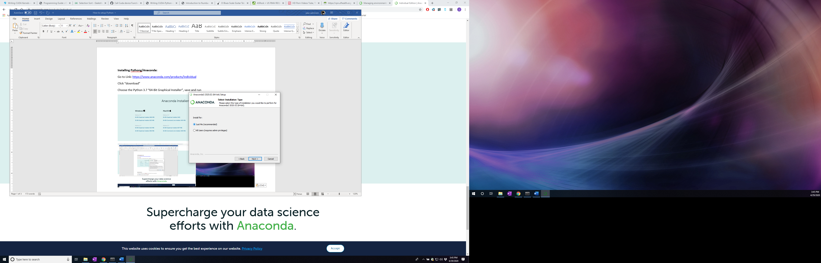

3) Use default path



4) DO NOT check these boxes they can lead to serious errors in the functioning of the program.



**Opening Existing env:**

*Make sure to have Anaconda installed before this step

**If you have an export env (e.g. “SPARCsert”), copy and paste it into your anaconda file:

[Drive-Letter]://Users/[username]/anaconda3/envs/

Now open Anaconda Prompt and enter command:

“conda activate SPARCsert”

**Creating env from .yml file**

Download .yml file from the “Docs” folder in the GitHub and put it in a folder you’ll remember.

Open “Anaconda Prompt”

Enter: “conda env create -f <path_to_yml_file>”

If you already have the env installed you’ll get this error message:

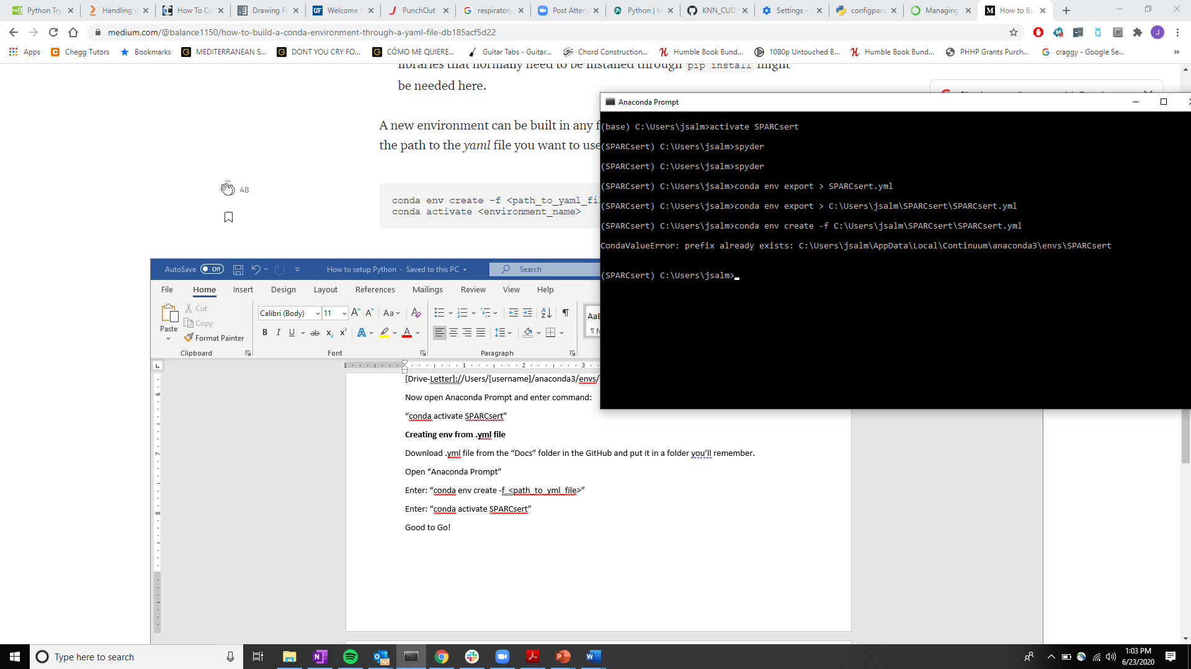

Enter: “conda activate SPARCsert”

**Good to Go!**

**Creating Virtual env:**

Go to: Anaconda Prompt

#create a new environment in the Anaconda Prompt

Type: “conda create -name [insert name here] python=3.6” ; type “y” and press [enter]

#Activate your new environment and install Keras, spyder,

Type: ”activate [insert name here]”

Type: ”conda install -c anaconda keras-gpu” and press [enter]; *wait*

type “y” and press [enter]

Type: “conda install spyder” and press [enter]; *wait*

type “y” and press [enter]

Type: “conda install -c anaconda pandas” and press [enter]; *wait*

type “y” and press [enter]

Type: “conda install -c anaconda scikit-learn” and press [enter]; *wait*

type “y” and press [enter]

Type: “conda install pillow” and press [enter]; *wait*

type “y” and press [enter]

Type: “pip install matplotlib”

Type: “pip install opencv-python”

Type: “pip install scikit-image”